**Pharmacy Management System**

Group Members:

Sasidhran Thuthikulam Selvakumar

Tamil Selvan Valathy Shanmugam

Saranya Prakash Babu

Lipsarani Sahoo

Vivek Ravi

**Introduction**

Pharmacy management system deals with the maintenance of drugs and consumables in the pharmacy unit. The set-up of this pharmacy management system will ensure availability of sufficient quantity of drugs and consumable materials for the patient. This will enhance the efficiency of clinical work and ease patient’s convenience, bearing in mind that in Ethiopia is heading towards pharmaceutical care of patients. In addition, Pharmacy management system will be able to process drug prescription with ease. PMS (Pharmacy Management System) will design to detect drug interaction.

In general, The Pharmacy management system is based on computer technology that gives service for users, managed by the pharmacist who give implementation of function relatively in effective times as well as will design for removing time wasting, saving resources, easy data access of the medicine, security on data input and data access by removing almost manual based system.

**Project description**

The pharmacy management system provides functions on identify medication usages instruction, minimize human errors in medication safety, facilitate accessibility of drugs’ information and information management among employees, providing optimal drugs movement in pharmacy unit, enable reports with in significantly short period of time, despite simultaneous usage of database for the purpose stated above.

The system will solve the problems by minimizing time wastage and reduce resources which simply change manual based system to computerized system.

**ER Diagram:**

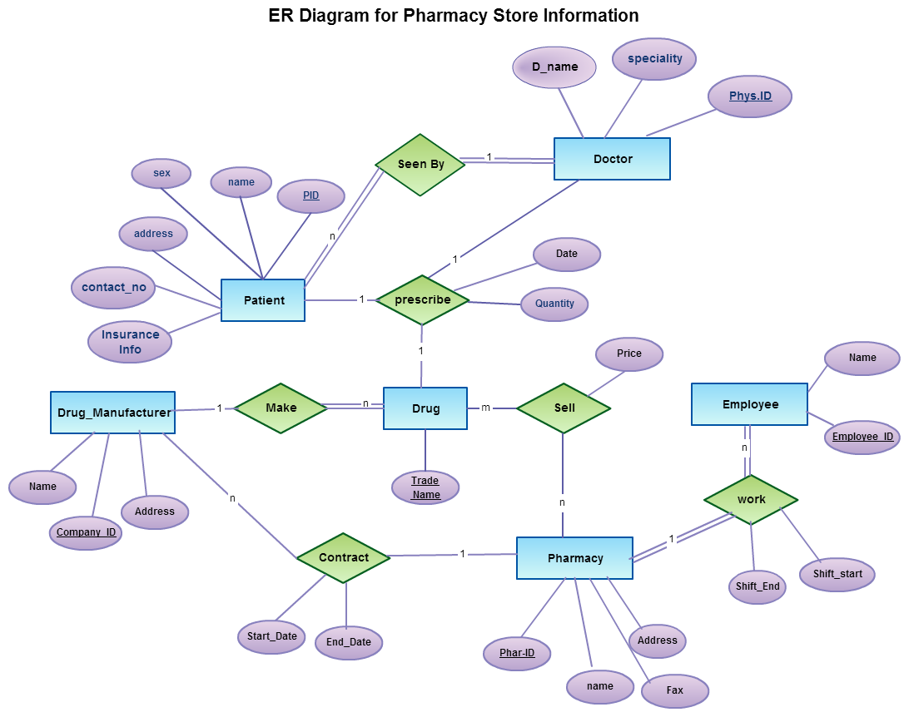

**Data Flow Diagram**



**UML**



**Database:**

Oracle 11g

**Tools Used:**

Oracle Sql Developer

Informatica 9.6.1

**Screen shots**

Fact table and list of dimension tables:

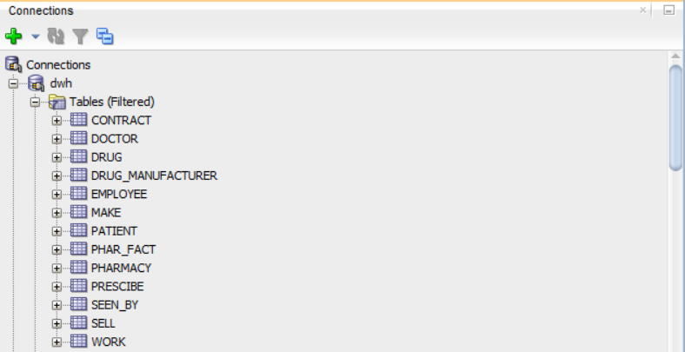

**Fact table code:**

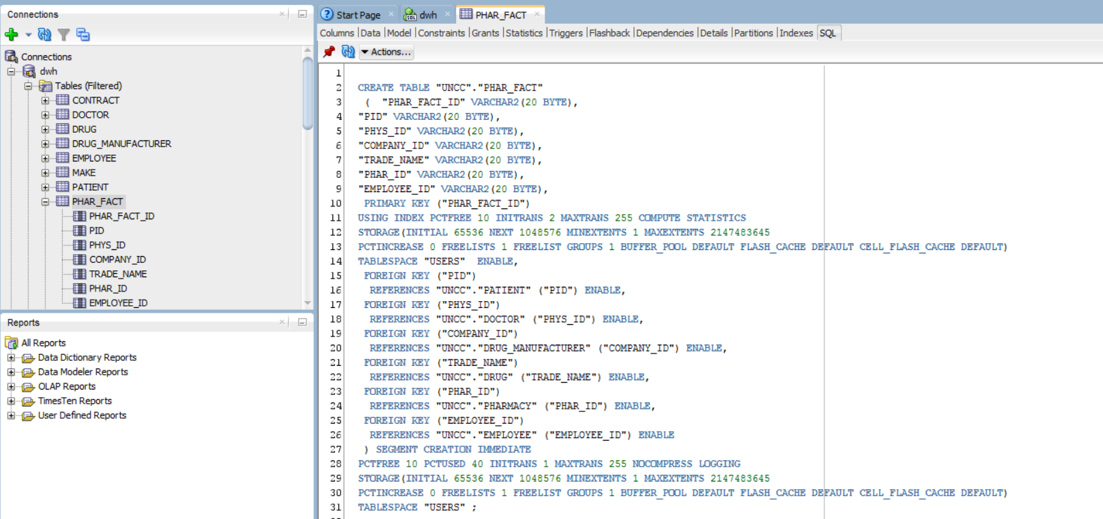

**Informatica Admin Repository and Integration Service:**

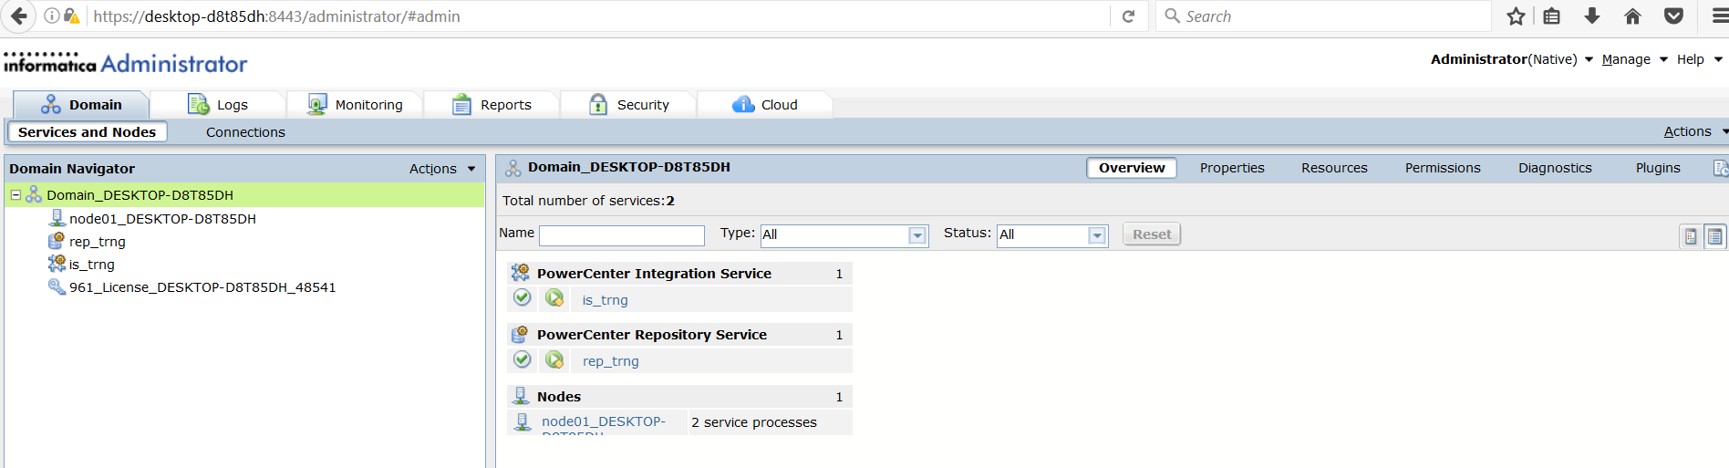

**Repository Service:**

This shows the repository service is up and available for data loading.

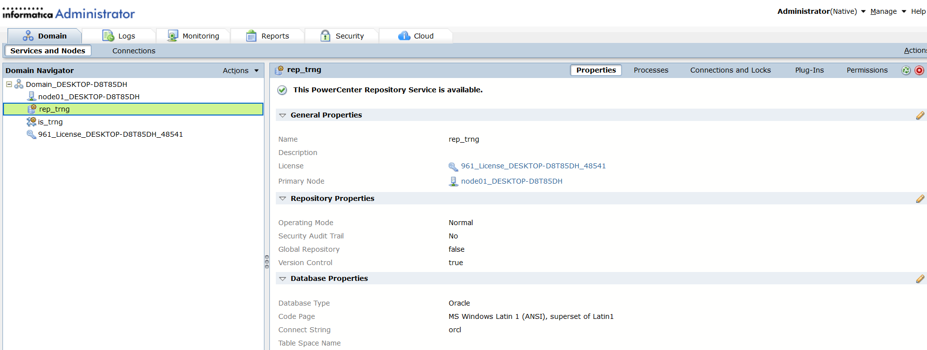

**Integration Service:**

This shows the integration service is up and available for data integration.

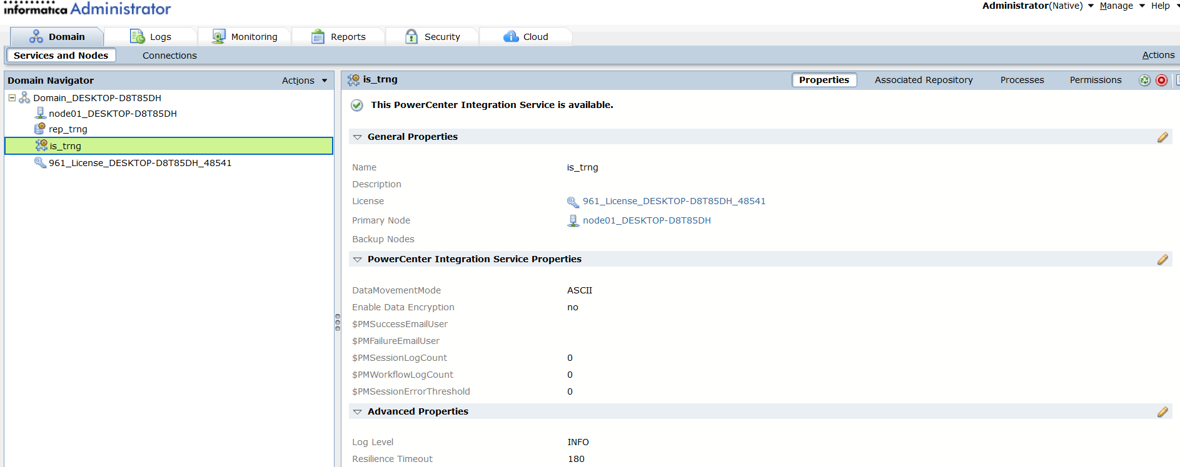

**Data Repository mapping:**

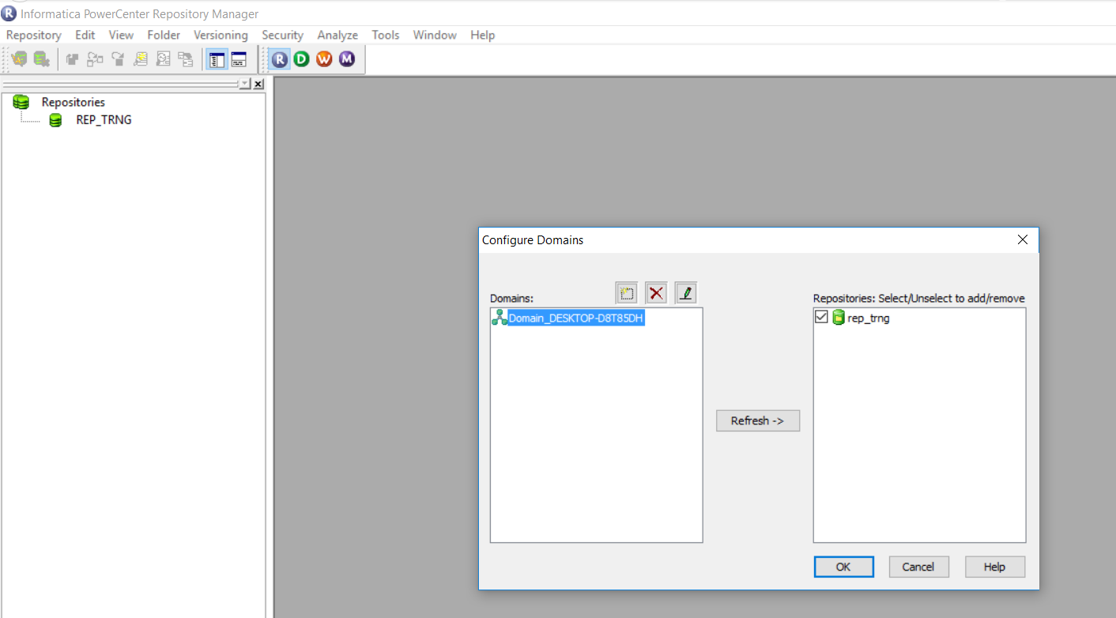

**Establishing connection with database to retrieve the data from source table**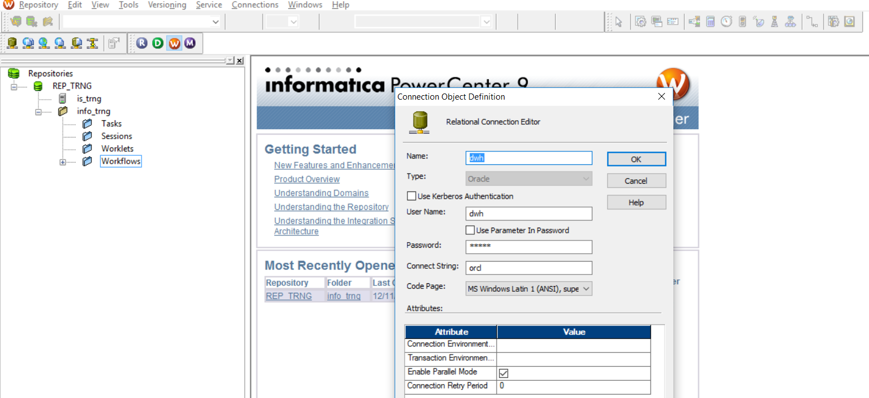

**Source table for mapping:**

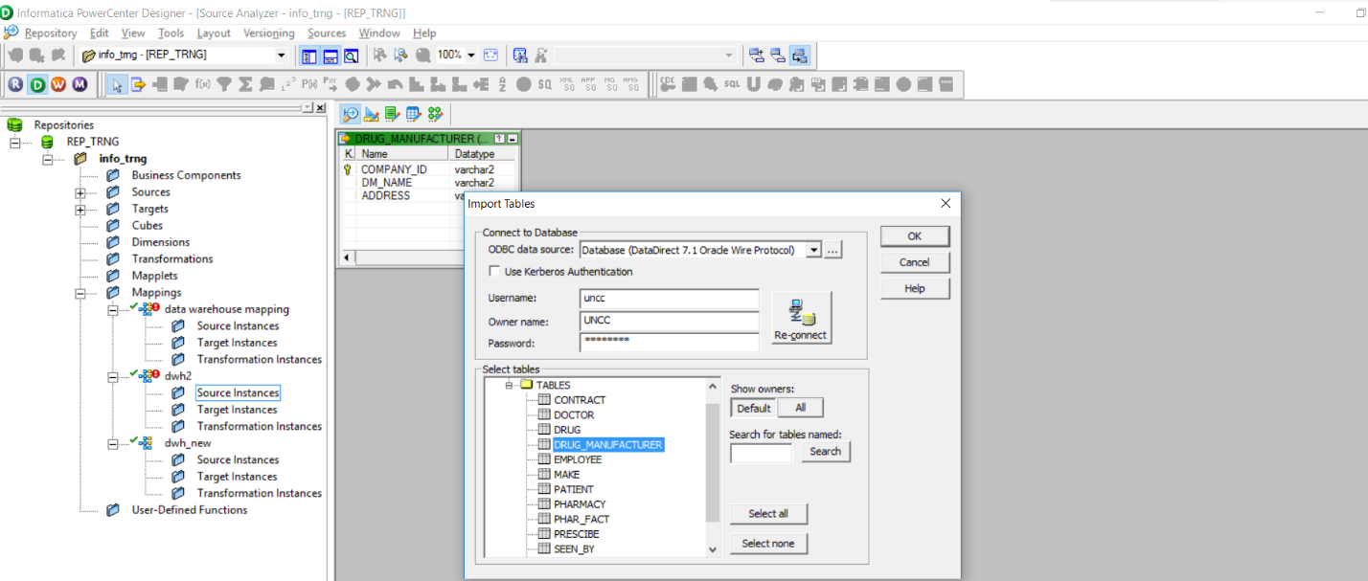

**Creating mapping logic between the source and the target tables:**

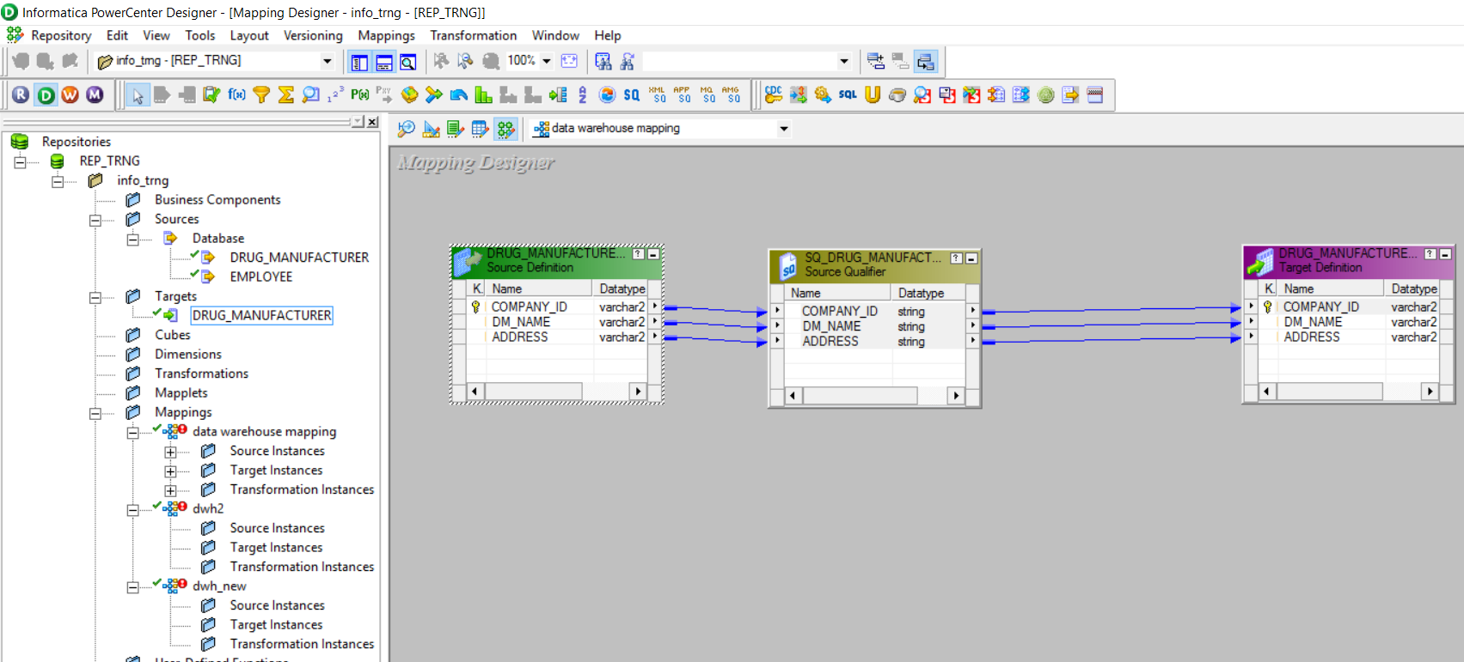

**Confirms that the mapping logic is valid.**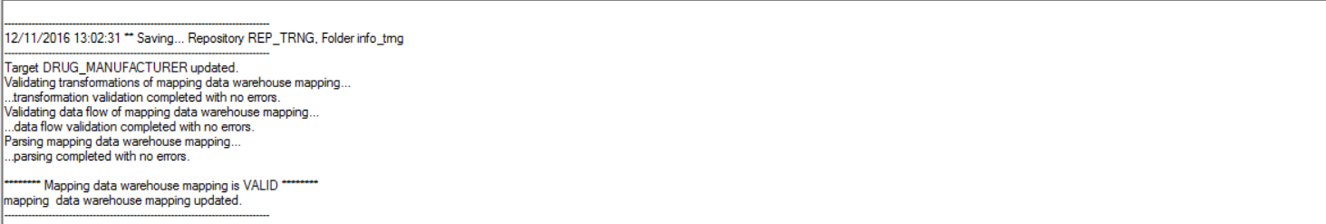

**Source and target mapping of the ETL process**

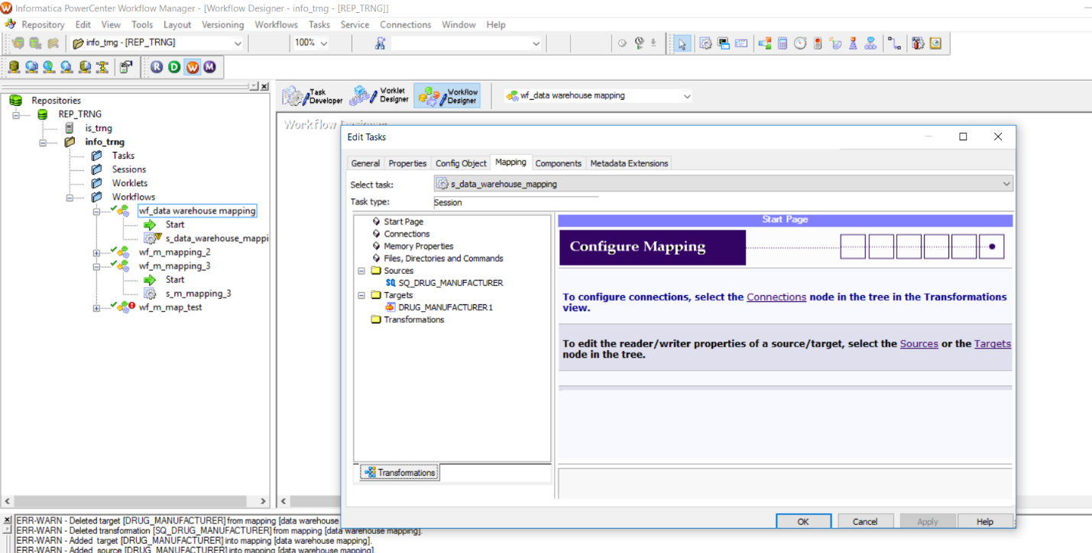

**Data getting loaded into the target table**

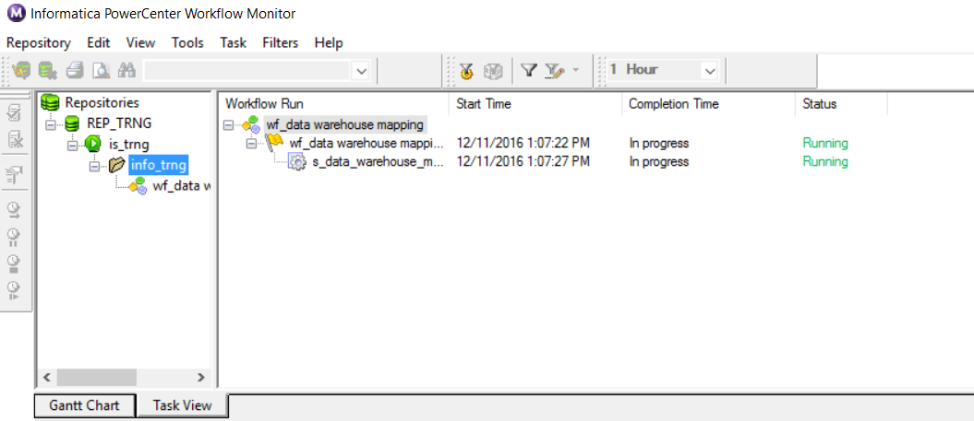

**Conclusion**

The pharmacy management system enables dispensation process. It stores all the physicians’ prescription of the patients. A summarized list of drugs dispensed to the patient can be viewed for monitoring purposes. This accessibility of the information will be great advantage as it reduced further medical errors associated with physicians and nurses.